AEI X001252

To: CIOB Member

ABC Services 2 x £50.00 £100.00

XYZ Services 5 x £80.00 £400.00

Net Total £500.00
VAT 17½% £ 87.50
Total £587.50

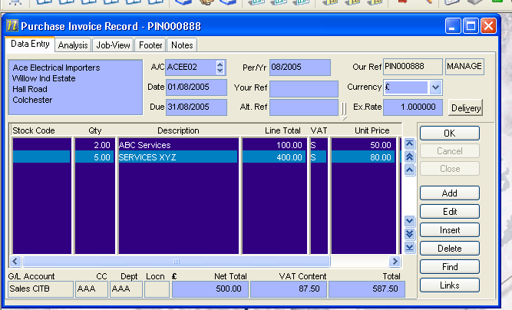

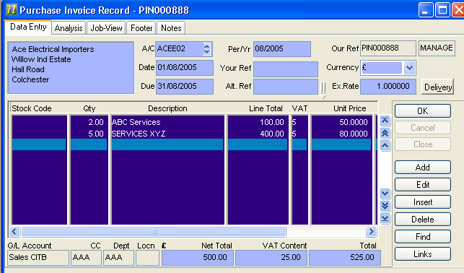
User enters invoice details as per the supplier invoice but selects the appropriate Partial Exemption VAT Code instead of the standard 17.50% code.

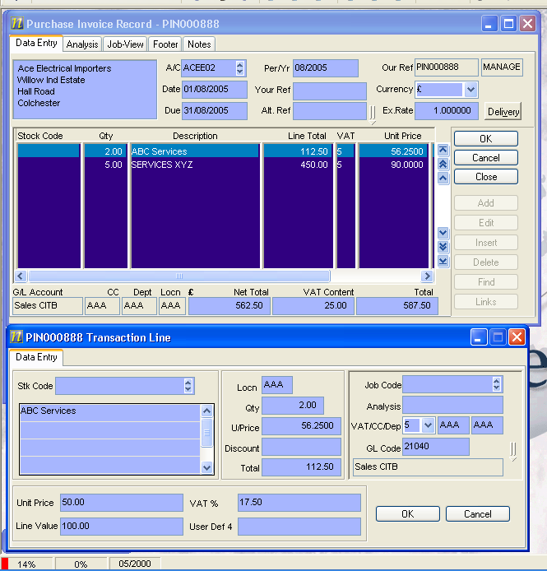
VAT Exemption Hook recalculates the Unit Prices and saves the original values within the transaction lines.

